|  |  |
| --- | --- |
| Assignment 1 Hadoop  ITRI 623 | ENRICO DREYER  31210783 |

Table of Contents

Introduction 2

Proof 3

My Random notes of the course: 3

Practical: 4

References 5

# Introduction

For this assignment we were asked to make a video of no longer than 2 minutes on any two sections of the Hadoop Udemy Course. For the first Assignment I decided to go with the basics of Hadoop, this being HDFS and MapReduce.

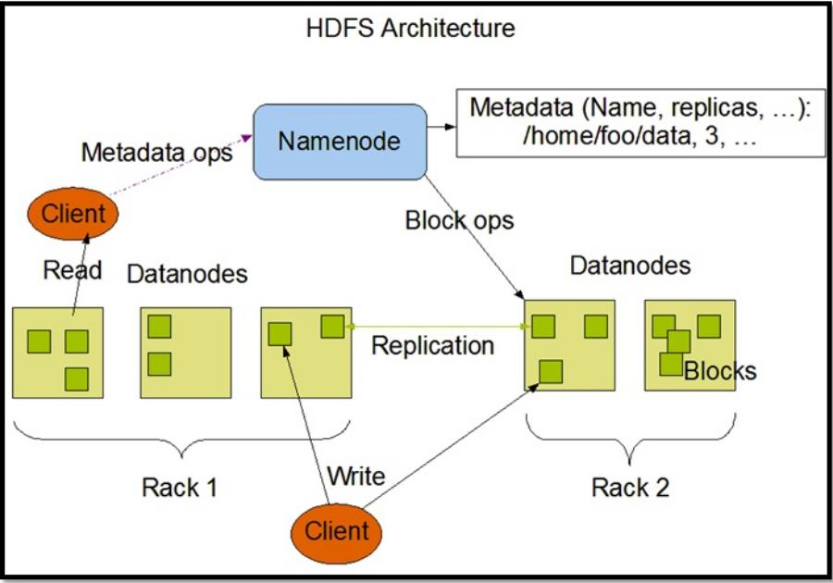

The following section of the document will discuss the notes of my video

# Proof

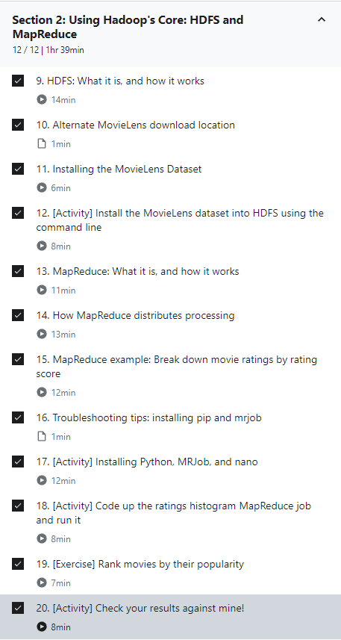

# My Random notes of the course:

The Ultimate Hands-On Hadoop: Tame your Big Data!

**HDFS Architecture** - HDFS works by having a main ‘NameNode’ and multiple ‘data nodes’ on the same commodity hardware cluster. All nodes are almost always grouped in the same physical rack in the data center. Then data is broken down into different ‘blocks’ that are shered among the different data nodes for storage. Blocks are also make an exact copy of across nodes to reduce the chances of failure. (Nicolas, 2014).

**Putty cmd -** PuTTY (/ˈpʌti/) is a free and open-source terminal emulator, serial console and network file transfer application.

**hadoop fs -ls** For a directory: returns the list of directories and file, for a file: returns the statistics on the file.

hadoop fs -lsr: recursively listing the files and directories under the specific folders.

Example: Hadoop fs -ls / or hadoop fs -lsr

**MapReduce** is for writing applications; it is a programming model that can process Big Data in a parallel manner on more than one node at a time. MapReduce has the ability to provide analytical capabilities for analyzing big amounts of complex data. (Phoenixnap, 2020)

**Key-Value Pair (KVP) Mapping** is the process of linking the key to its associated value. While mapping, if the key ‘firstName’ is associated with a value ‘Bugs’, it means that the array maps the ‘Bugs’ to key ‘firstName’ (Servicenow, 2021).

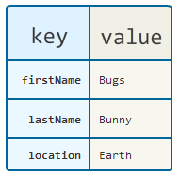

**Shuffle and Sort –** Theshuffle phase in Hadoop changes the map output from Mapper to a Reducer in MapReduce. The sort phase in MapReduce covers the sorting and merging of map outputs. The data from the mapper are grouped by the key, then split among reducers, and then sorted by the key. Every reducer gets all the values associated with the same key (DataFair, 2021).

**Hadoop Streaming** – The reducer and the mapper are executables that can read the input line by line and emit the output to line by line. The utility can then create a MapReduce job, submit the job to an appropriate cluster, and monitor the progress of the job until it completes.

# Practical:

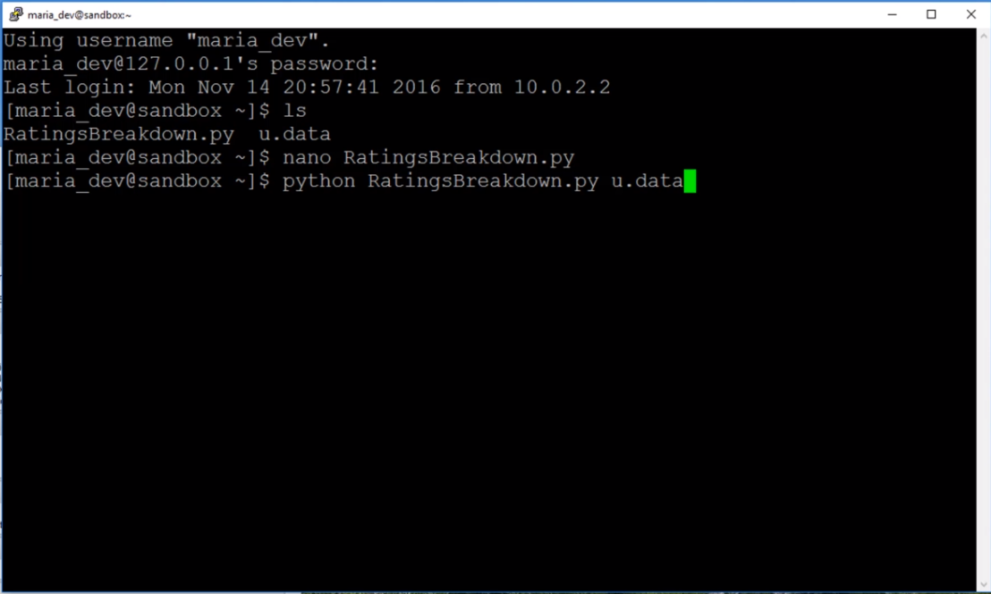

Map – reduce – sort

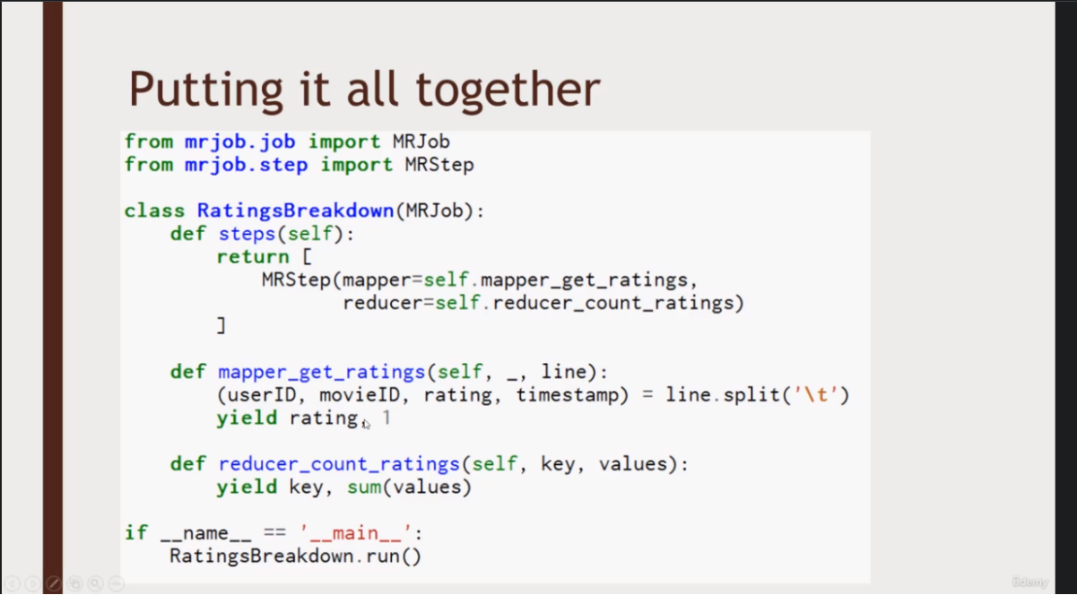

This is specific to counting the movies for each rating.

# References

DataFair. (2021). Shuffling and Sorting in Hadoop MapReduce. <https://data-flair.training/blogs/shuffling-and-sorting-in-hadoop/>

Nicolas. (2014). WHAT IS HADOOP AND HOW DOES IT WORK? <https://dataconomy.com/2014/02/hadoop-what-how-introduction/#:~:text=The%20way%20HDFS%20works%20is%20by%20having%20a,distributed%20among%20the%20various%20data%20nodes%20for%20storage>.

Phoenixnap. (2020). What is Hadoop Mapreduce and How Does it Work. <https://phoenixnap.com/kb/hadoop-mapreduce#:~:text=MapReduce%20is%20a%20processing%20module%20in%20the%20Apache,use%20low-cost%20consumer%20hardware%20to%20handle%20your%20data>.

Servicenow. (2021). Create a key-value pair mapping. <https://docs.servicenow.com/bundle/rome-now-intelligence/page/use/reporting/task/t_CreateKeyValuePairMapping.html>